AICTL - Fall 2025

**Final Project Report**



**Submitted By:**

* **Hooriya Sohail (2025-CS-137)**
* **Mahnoor Asmat(2025-CS-158)**
* **Amna Arshad (2025-CS-164)**
* **Tayyaba Sohail (2025-CS-141)**
* **Dua Zehra (2025-CS-134)**
* **Azbah Naveed (2025-CS-170)**

**Course Instructor:**

* **Ms Ramsha Khalid**

Department of Computer Science

University of Engineering and Technology Lahore

Table of Contents

**1.** **Exclusive summary** 3

**2. Introduction: The Digital Gateway to Cappadocia** 4

**2.1 Introducing: “Aeris Cave Resort”** 4

**2.2 Website Structure and Features** 4

**2.2.1 The Homepage (The Visual Narrative)**The homepage serves as the "Grand Lobby" of our website. It introduces our main scenario: a sanctuary for those seeking to disconnect from the modern world and reconnect with history. It features: 4

**2.2.2 Room & Suites Gallery (The Living Experience)** 5

**2.2.3 Packages and Activities (The Adventure)** 5

**2.3 Website Structure and Features** 5

**3. Project Objectives and Scopes:** 5

**4. Sites Structures and Navigations:** 6

**4.1 Home Page** 6

**4.2 Packages Page** 10

**4.3 Rooms Page** 17

**4.4 Experiences Page** 20

**4.5 Contact Us Page** 29

**5. Design Choices** 31

**5.1 Fonts Families:** 31

**5.2** **Font Colors:** 31

**5.3 Layout and Structure Decisions** 32

**6.** **Assets Used** 32

**7.** **How to Publish the site** 32

**8.** **Reflection** 32

**9.** **Graphs and Charts ( from EXCEL )** 33

**10.** **Website Brochure** 36

**11.** **LinkedIn Screenshot** 37

# **Exclusive summary**

Located in the heart of beautiful Cappadocia, Turkey, **Aeris Cave Resort** is a special place where nature meets luxury. Our resort is built directly into ancient volcanic rocks, offering you a peaceful stay in one of the most unique landscapes in the world. At Aeris Cave Resort, we help you step away from the busy modern world and reconnect with history. Sleep in cozy, authentic rooms carved right into the stone, featuring modern comforts like heated floors and soft Turkish linens. Wake up to a sky full of hot air balloons, go horseback riding at sunset, or enjoy a relaxing Turkish spa session. We have special plans for everyone, whether you are on a romantic honeymoon, a family adventure, or a fun trip with friends.

# 

# **2. Introduction: The Digital Gateway to Cappadocia**

In the modern era, a website serves as more than just a digital platform it is the main touchpoint between a brand and its clients. By using HTML (Hyper Text Markup Language) to provide the structural foundation and CSS (Cascading Style Sheets) to design the visual aesthetics and responsiveness, we have built a platform that translates complex data into a self-explanatory user journey.

## **2.1 Introducing: “Aeris Cave Resort”**

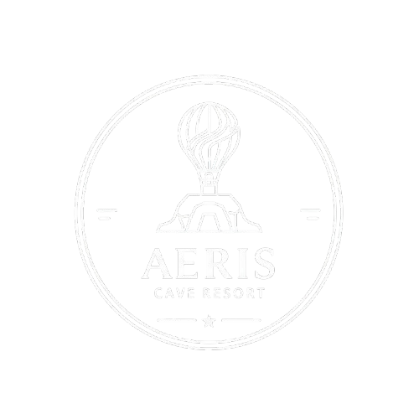

Our project focuses on a fictional, high-end escape resort present in the heart of Cappadocia,Turkey. Known for its "fairy chimneys," ancient caves and valleys and sunrise balloon launches, Cappadocia offers a unique landscape that requires a specific colored and thematic approach. Our resort is designed to blend seamlessly into the volcanic rock formations, offering a "luxury-meets-nature" escape. The main purpose of this website is to provide potential guests with a seamless digital platform into the pleasant atmosphere of the resort, offering clarity on our theme, luxury accommodations, and curetted local experiences.

## **2.2 Website Structure and Features**

**2.2.1 The Homepage (The Visual Narrative)**The homepage serves as the "Grand Lobby" of our website. It introduces our main scenario: a sanctuary for those seeking to disconnect from the modern world and reconnect with history. It features:

* An immersive hero section showcasing the Cappadocia skyline.
* A brief overview of our "Cave-Chic" philosophy.
* Exclusive packages for couples, newlyweds, spa enthusiasts and much more.

### **2.2.2 Room & Suites Gallery (The Living Experience)**

Drawing inspiration from the real "Cave Hotels" of the region, this section highlights our unique accommodation. We have designed pages for:

* **Standard Cave Rooms:** Cozy, authentic rooms carved directly into the tufa rock.
* **Delux Cave Suites:** Featuring private indoor pools and terraces with views of the Valleys.
* **Premium Cave Suite:** Detailed specifications on amenities, blending ancient architecture with modern comforts like heated floors and artisanal Turkish linens.

### **2.2.3 Packages and Activities (The Adventure)**

A stay in Cappadocia is defined by exploration. This page provides a detailed breakdown of real-world activities tailored for our guests:

* **Hot Air Balloon Expeditions:** Sunrise flights coordinated with local pilots.
* **Valley Sunset Horseback Riding:** Guided tours through the Rose and Red Valleys.
* **Wellness and Relaxation Retreats:** To provide relaxation and peace to minds and souls.
* **Private Vineyard Tours:** Exploring the ancient winemaking traditions of the Anatolian plateau.
* **Adventure Trips:** Adventure trips for friends/squads who are adventure enthusiasts.

## **2.3 Website Structure and Features**

This project was developed using a clean, semantic HTML structure to ensure accessibility and SEO friendliness. The visual identity including the earthy color palette, typography, and layout was meticulously crafted using CSS. We focused on creating a responsive design that mirrors the elegance of the resort itself, ensuring that the beauty of Cappadocia is translated perfectly onto any screen size.

# **3. Project Objectives and Scopes:**

* Sticky Navigation Bar: A menu that stays at the top of the screen as the user scrolls for easy access to different pages.
* Brand Immersion: To create a digital environment that reflects the unique "Cave Luxury" aesthetic of Cappadocia, using earthy tones and high-quality imagery.
* Information Architecture: To organize complex information room types, seasonal packages, and facilities details into a logical and easy-to-navigate way.
* User Conversion: To provide a professional booking environment where the interface and action of the website encourages users to explore rooms and activities.
* Cultural Representation: To accurately represent the local heritage and geography of Turkey, ensuring the fictional resort feels grounded in reality.
* Responsive Layout: The website adapts to different screen sizes (desktops, tablets, and phones) using CSS media queries.
* Hero Video and Image Slider: A prominent header section showcasing the iconic hot air balloons of Cappadocia.
* Quick Look Sections: Brief, high-impact cards that link users directly to the most popular suites or the activity page provided on the homepage.
* Room Detail Pages: Individual sections for each room type providing a list of facilities e.g., cave rooms, cave-carved fireplaces.
* High-Resolution Galleries: Image grids styled with CSS to showcase the unique stone architecture of the rooms.
* Categorized Activity Grids: Hover effects on images that reveal details about activities like "ATV Tours" or "Traditional Turkish Breakfasts."
* Price Transparency: Clear pricing tables or "starting from" labels for various holiday packages e.g. Honeymoon Package, Adventure Package.

# **4. Sites Structures and Navigations:**

## **4.1 Home Page**

* **Navigation Bar**

The navigation bar is placed at the top of the website and provides the users with all the main tabs of the pages. It contains the five tabs/buttons i.e. Home, Packages, Cave Suites, Experiences, and Contacts as shown in the image provided below in the report.



It also contains the logo of the website at the top left corner of the home page.

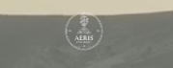

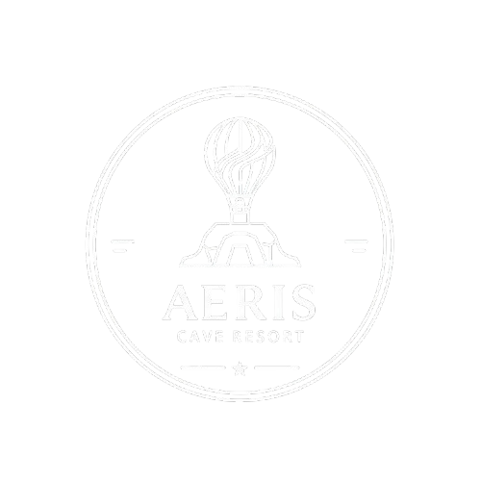

* **Main Display**

Just below the navigation bar is the main display of the home page. It contains the name of our resort, “ Aeris Cave Resort ”. It contains a beautiful ongoing video in the background with the a very pretty sky and hot air balloons activities. The “ Book Now ” button just below the resort name will take the user to the “ Contact Us ” page after clicking it.

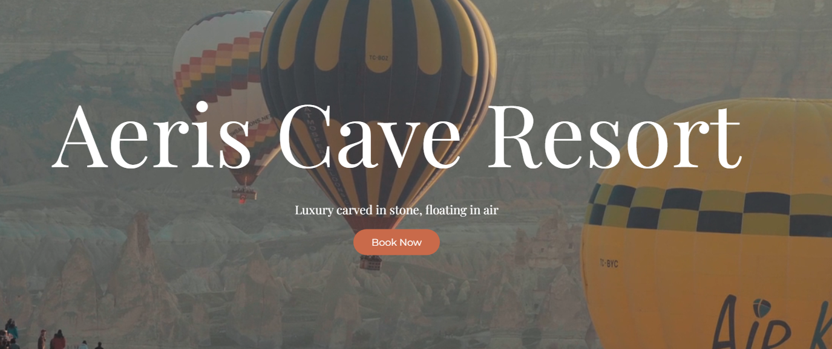

* **Hotel Ambiance**

Below the main display of the homepage is the hotel ambiance which gives us a graphical introduction about our resort, its key features, the facilities it provides along with the explanation of the theme of our website. Just after this introductory paragraph is the “ Explore Rooms ” button, after clicking on which the user will be able to explore different types of rooms and residential packages provided on the rooms or cave suite page.

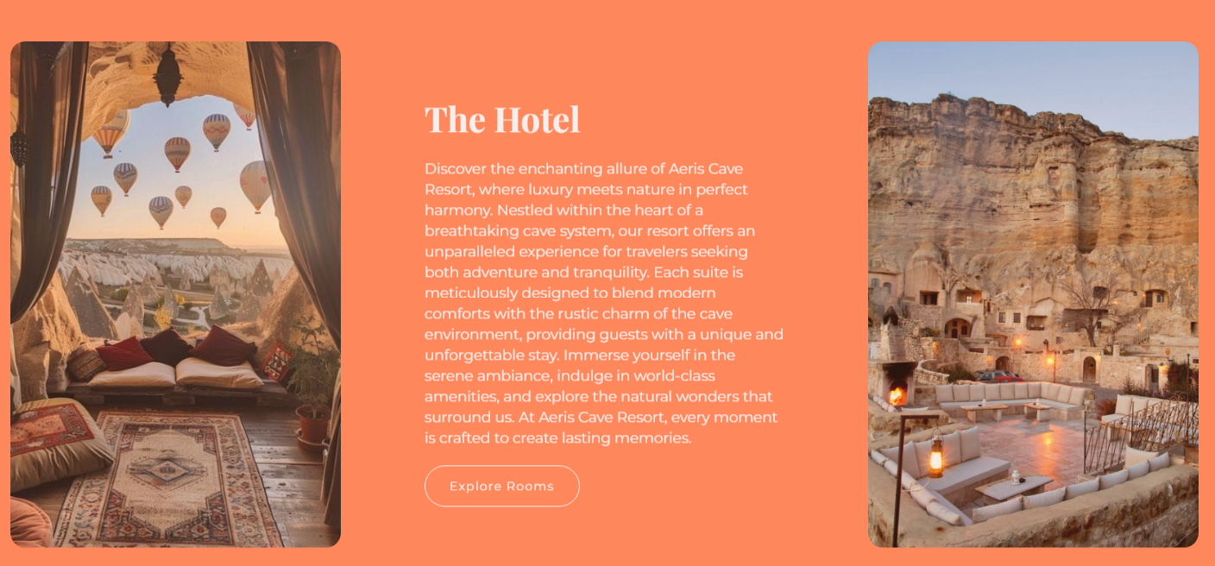

* **Featured Packages**

The second last feature available on the home page is the “ Featured Packages ” section. This section contains the menu for the packages provided for the users and the tourists. It also contains self-explanatory pictures for the packages for the ease of the users of the websites. After clicking on any of the featured packages in this section the user gets access to the “ Packages ” page of the website.

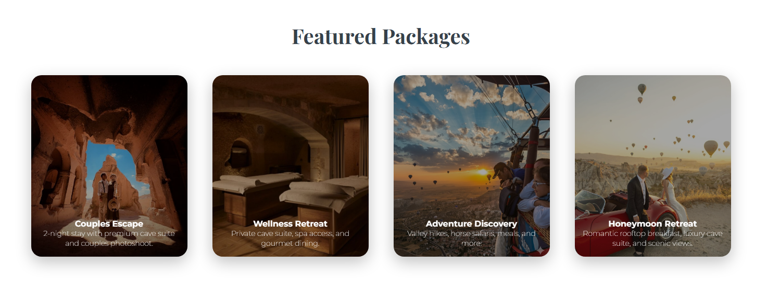

* **Featured Activities**

The last section of the home page is the featured activities section. The “ Activities in Cappadocia ” contains the activities provided for the tourists by the resort. These activities includes Hot Air Balloon Ride, Horse Riding, Pottery Activities and many more. After clicking any of the featured activities on the home page, the “ Activities ” page in the website is opened which containing in depth explanations and understandings provided by the resorts for the tourists.

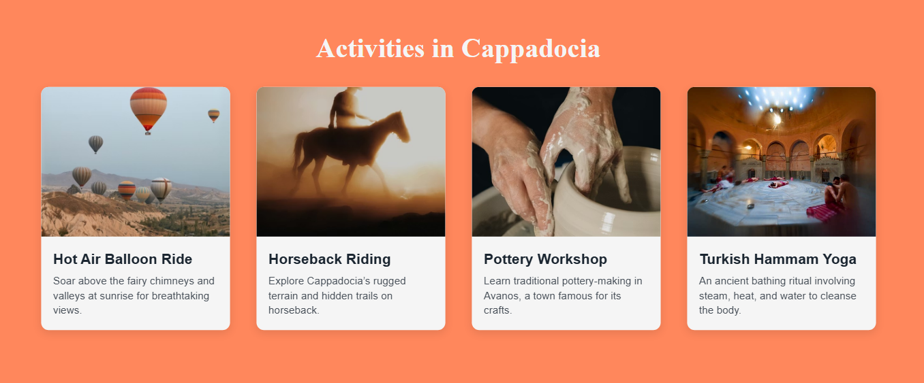

* **Footer**

The footer of the website is present at the end of all the pages in the website.

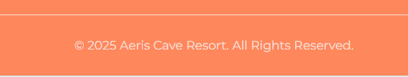

## **4.2 Packages Page**

* **Main Display**

The second page of this website is the “ Packages ” page. The main display of the page has a very pleasant video on which is stated “ Tailored Offers ” as shown in the picture below. It also contains the navigation bar as well as the logo of the website. On this page the user can get an insight of all the packages and activities provided by the resort. After viewing the packages the users can book them by clicking on the Book Now button given in the main display of this page.

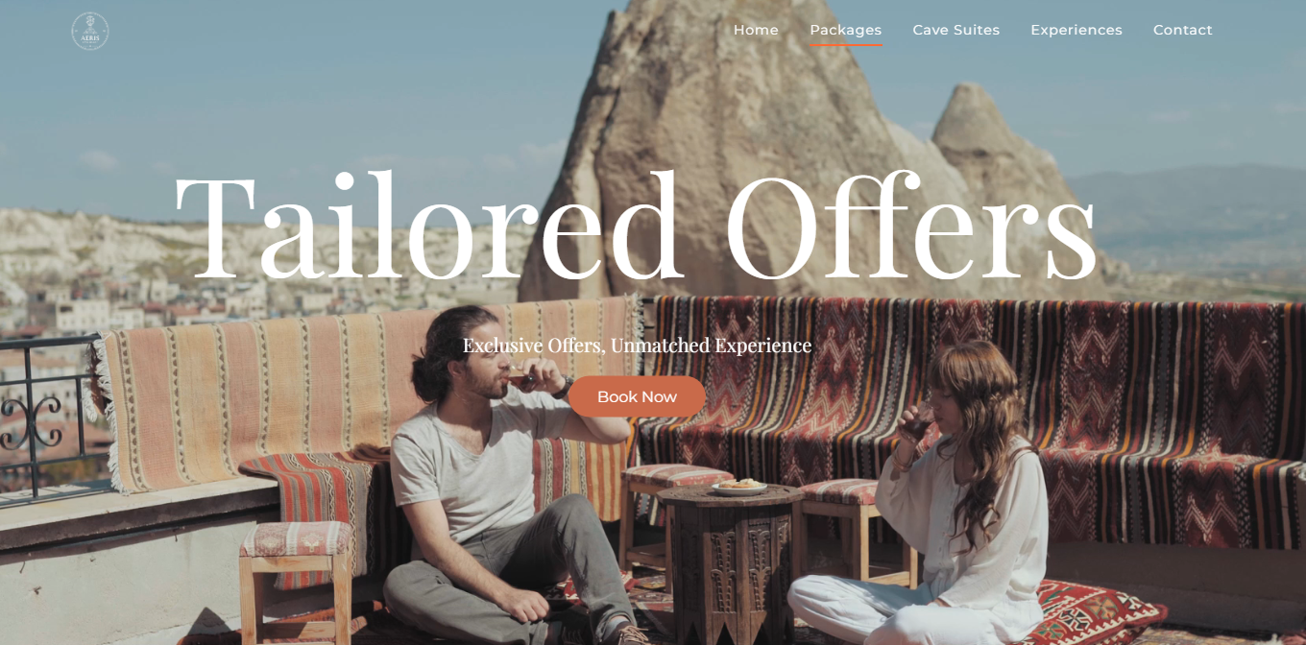

* **Exclusive Packages**

After the main display of this page comes the provided packages to the users and tourists along with the Names, package cost, and the facilities provided with each of the package. Further in this report is the detailed explanation of all the packages provided in this page with their pictures, cost details and further things that comes with each package.s

1. **Honeymoon Retreat**

This package is specially designed for couples who want a romantic and peaceful getaway. Guests stay in a premium cave suite, which gives a cozy and private experience. The highlight is a hot air balloon ride that lets couples enjoy beautiful views together. Luxury dining is included, along with aromantic rooftop breakfast that makes mornings extra special.

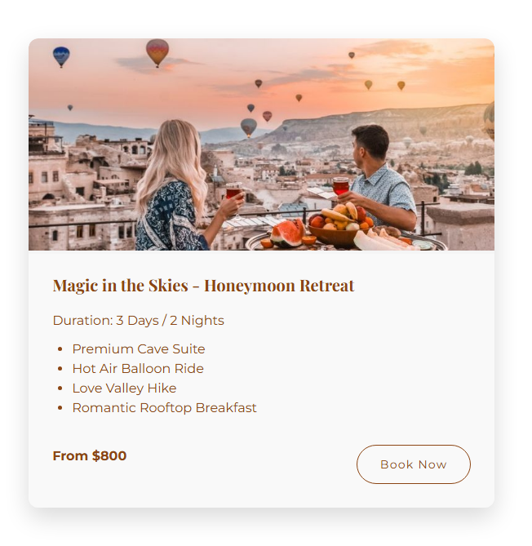

1. **Golden Dawn Luxury Couples Escape**

This is a high-end luxury package for couples who want comfort and elegance. Guests stay in a private luxury cave villa with beautiful interiors. The package includes a private jacuzzi decorated with roses for relaxation. Couples can enjoy a Turkish spa session and also get a professional photoshoot to capture special memories.

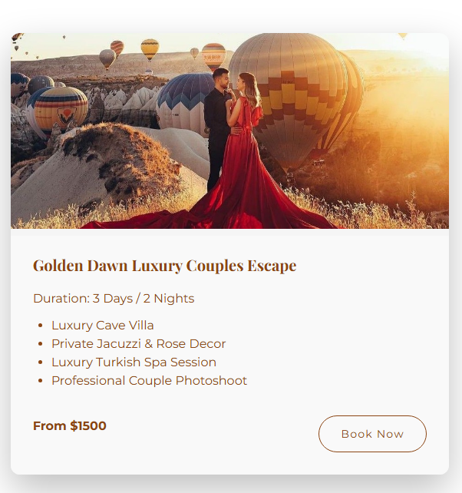

1. **Adventure Discovery- Family**

This package is perfect for families who love adventure and culture. Guests stay in a comfortable cave suite while enjoying fun outdoor activities. The family can explore the Sword Valley through hiking, go on a horse safari, and enjoy an ATV sunset ride. Cultural experiences like a Turkish night and pottery workshop make the trip educational and entertainment.

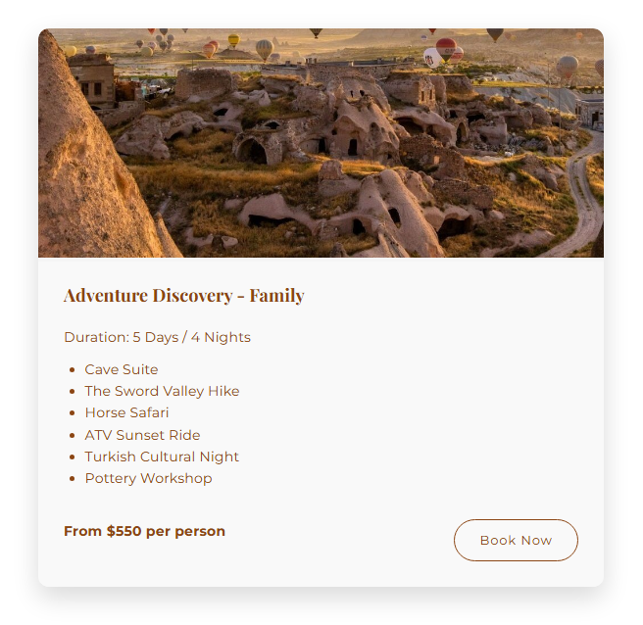

1. **Ride and Rise Combo**

This short but exciting package is for adventure lovers. Guests stay in a standard cave room and explore the local area through guided tours. The package includes a jeep safari adventure and horse-riding experience. The trip ends with a sunset hot air balloon ride, offering amazing views and a memorable ending.

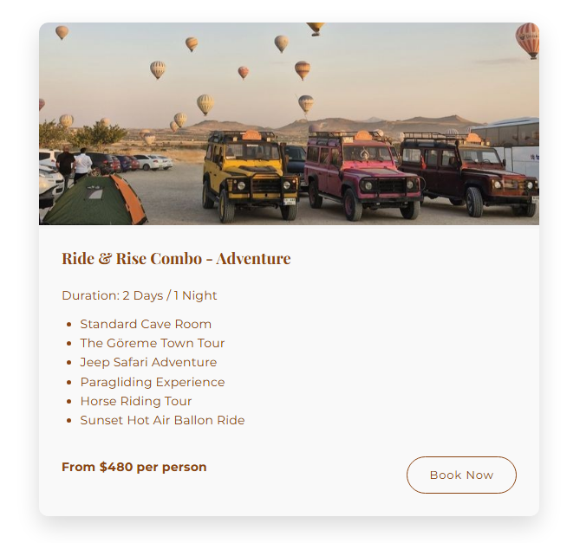

1. **Squad Goals Adventure Trip- Friends**

This package is best for friends traveling together. Guests stay in a cave suite and enjoy fun group activities. The trip includes a jeep safari, BBQ night, and visits to scenic viewpoints. Friends can take photos at famous photo spots, making this package perfect for bonding and creating memories together.

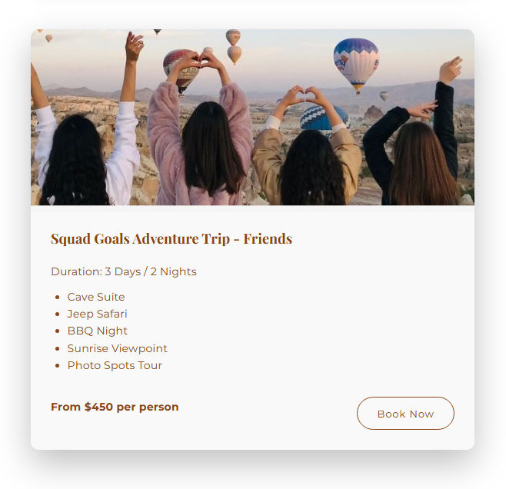

1. **Cappadocia Relaxation and Wellness Reatreat**

This package focuses on relaxation and mental peace. Guests stay in a premium cave suite at a spa hotel. The experience includes traditional Turkish hammam sessions, yoga and meditation, and a relaxing valley tour. This retreat is perfect for guests who want to relax, recharge, and escape from daily stress.

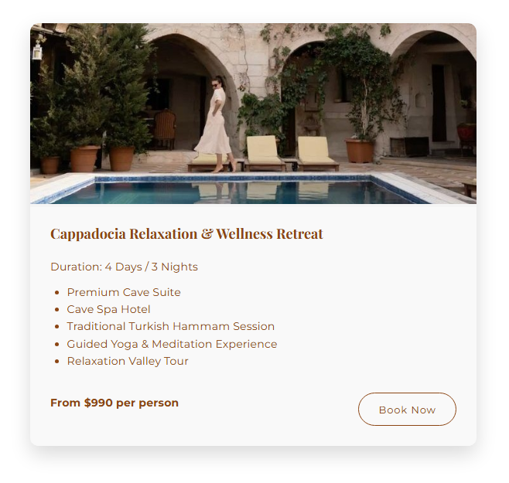

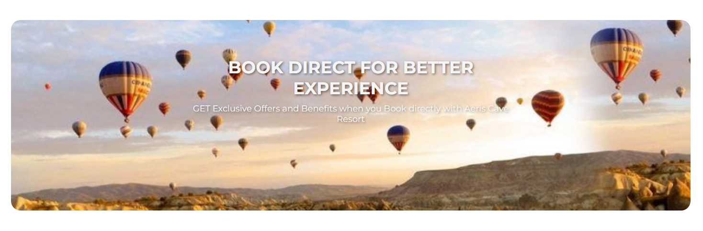

## **4.3 Rooms Page**

* **Main Display**

The third page of the website is the ” Rooms ” page. The main display of this room contains one of the rooms pictures and this page is entitled as “ Cave Suites ”. It provides the information and details about all the rooms packages available in the resort for the tourists. The website provides details about each type of room so that it’s easy for the users to select which type of room is suitable for them. The page further provides pictures of the rooms, size, cost prize as well. The whole website is built on the idea of self-explanatory features and so is this page.

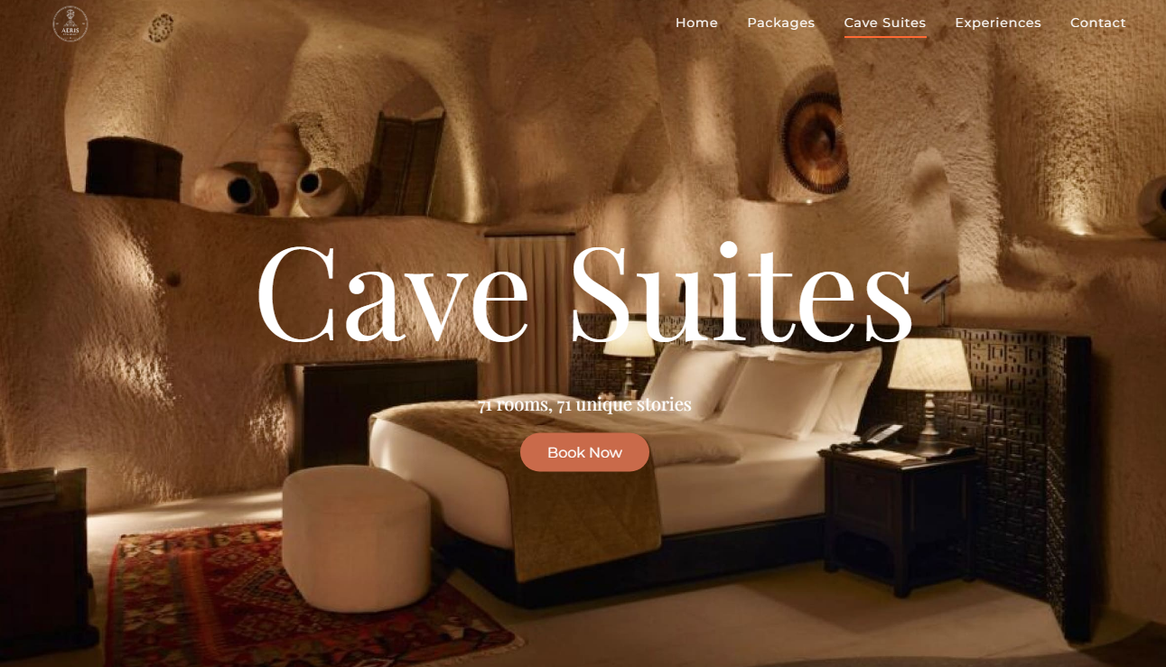

* **Rooms**

1. **Standard Cave Room**

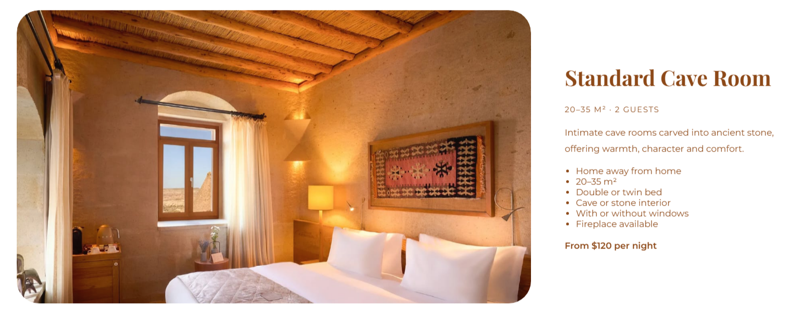

1. **Deluxe Cave Room**

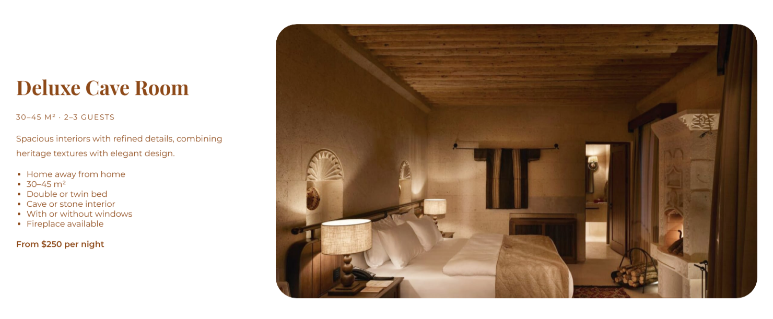

1. **Cave Suite**

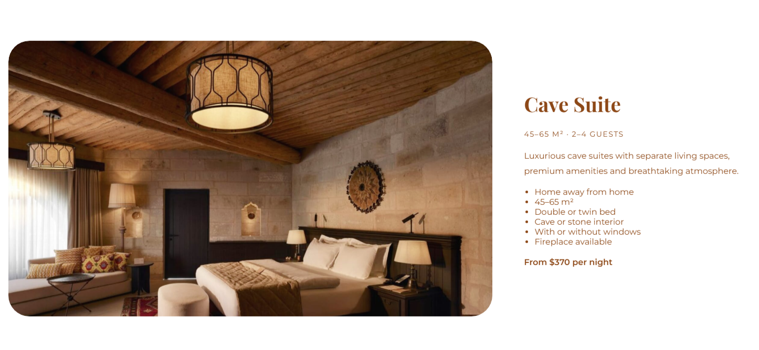

1. **Premium Cave Suite**

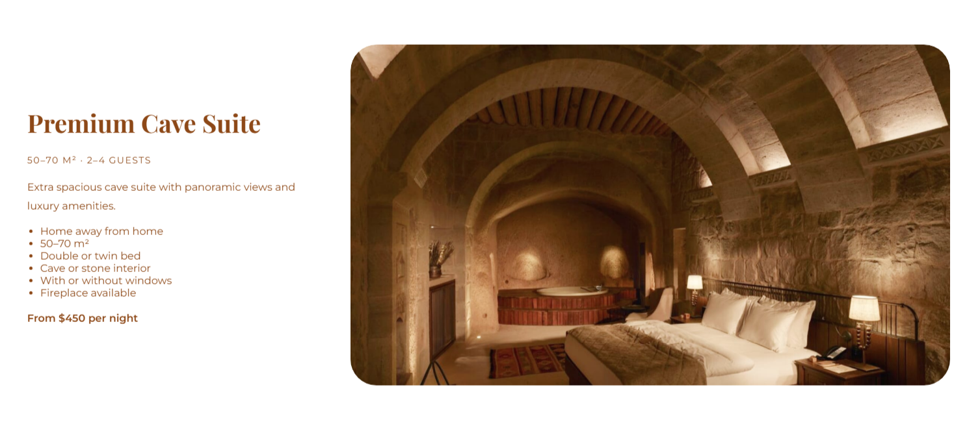

1. **Luxury Cave Villa**

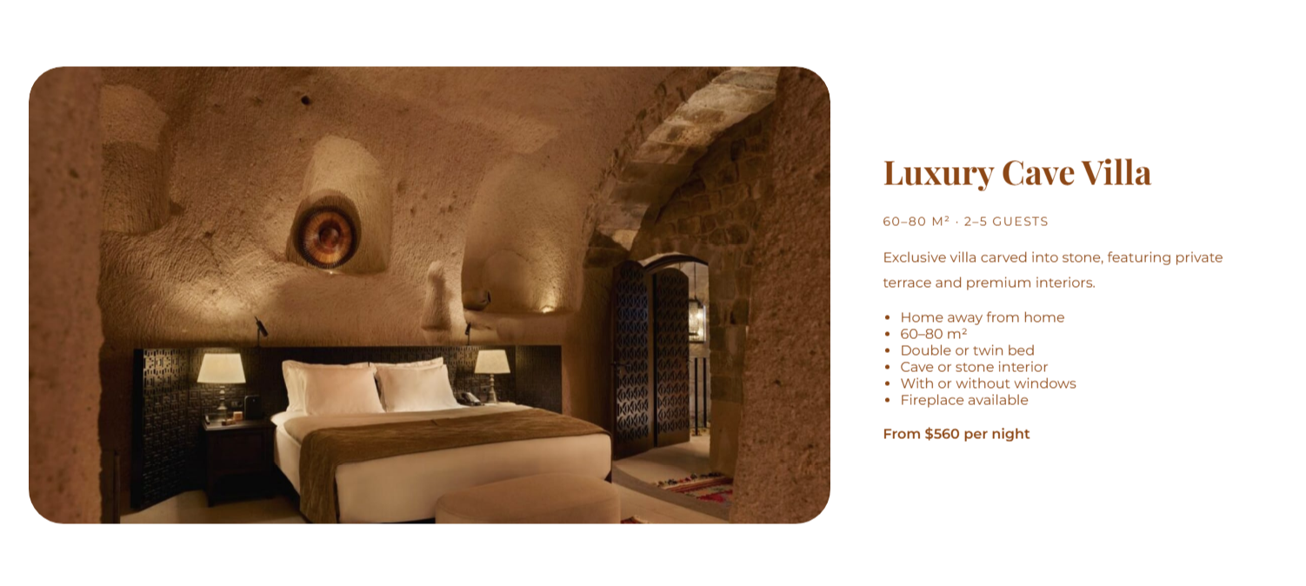

## **4.4 Experiences Page**

* **Main Display**

This page provides the user with all the details and information about the experiences provided by the resort. This page contains the main display as shown in the picture below. Here the user can also view all the activities and the experiences which the website contains and then just like the other pages, this page also provides the booking service. Some of the experiences includes air activities, stay in cave suites, tours of the surrounding natural viewpoints like valleys, forests, lake views, hiking, hot air balloon ride, horse riding, camel safari, pottery, sky diving, shopping, sightseeing of old and historical places, jeep rides, paragliding and many more.

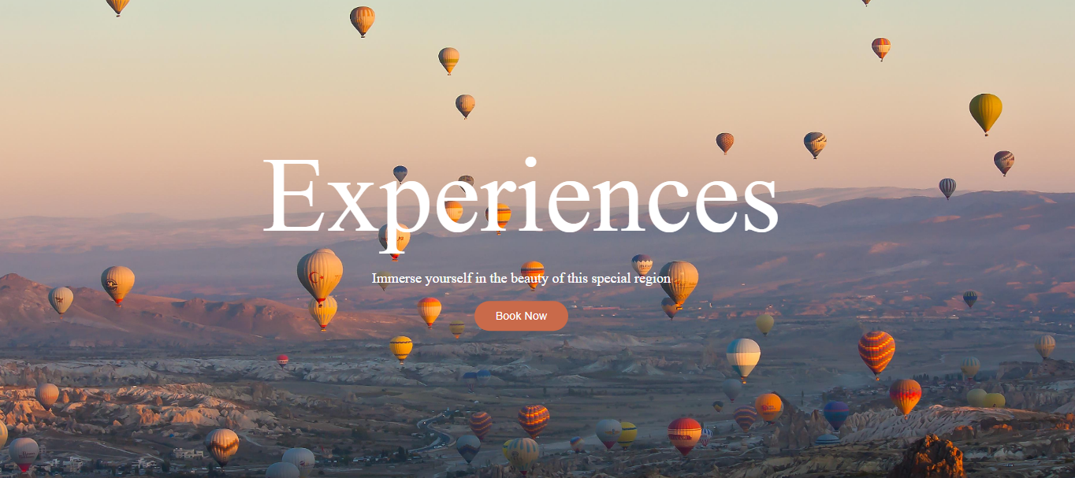

* **Unforgettable Experiences**

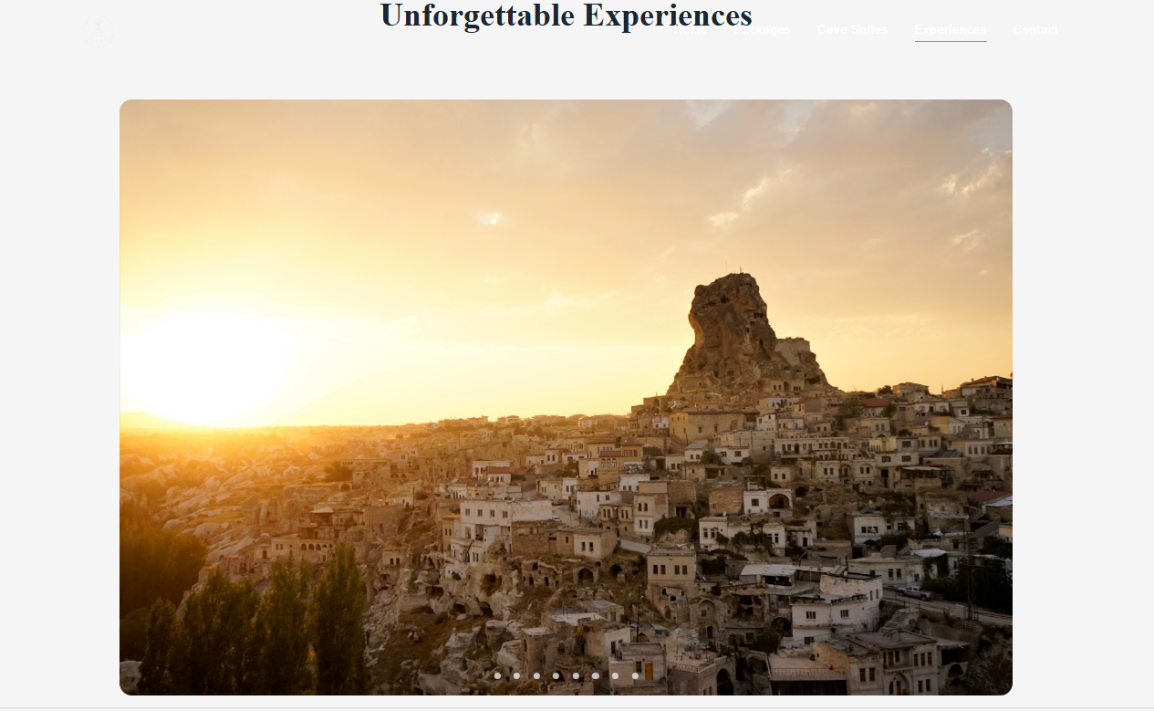

* **Experiences and Photos**

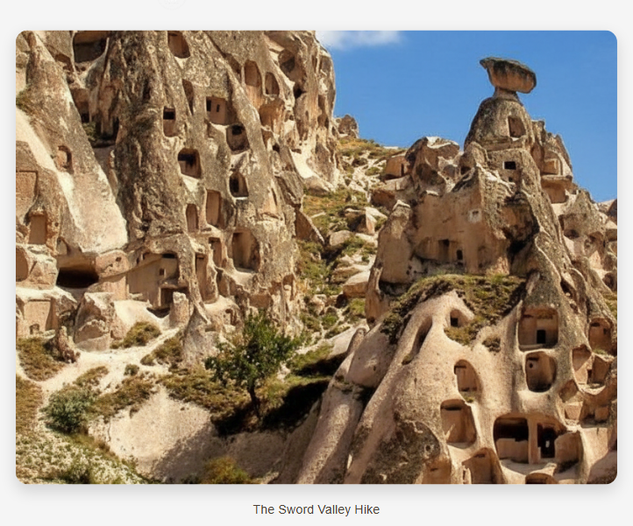

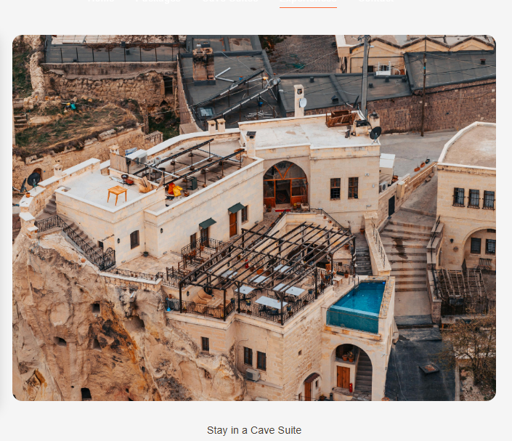

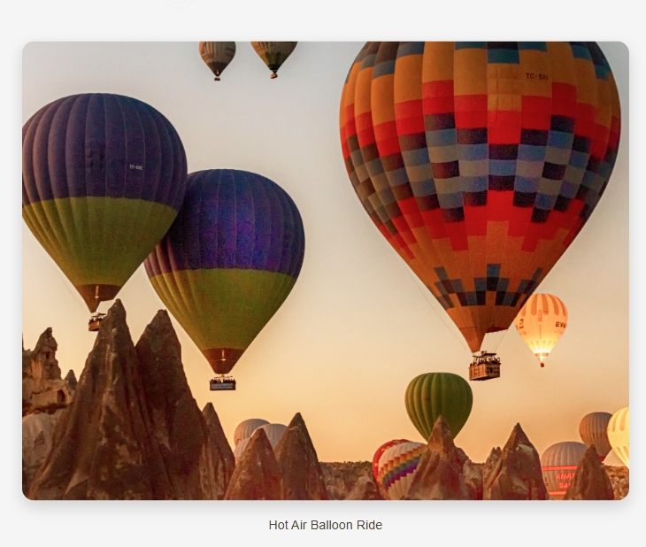

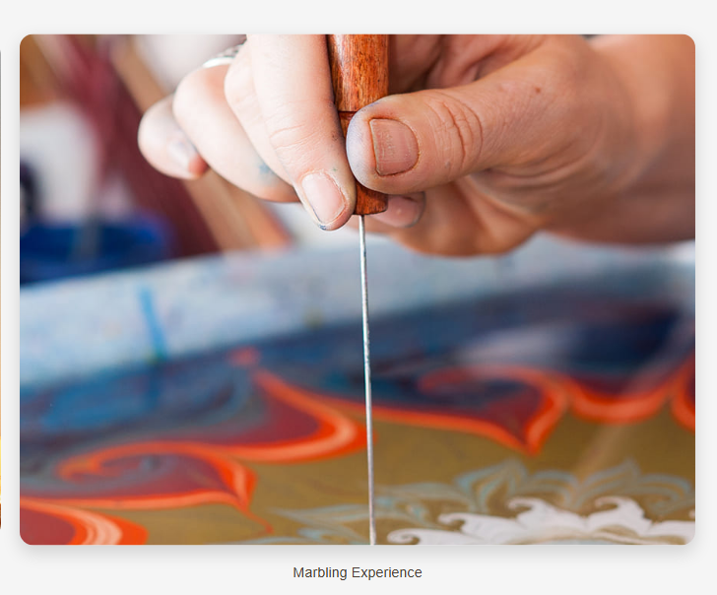

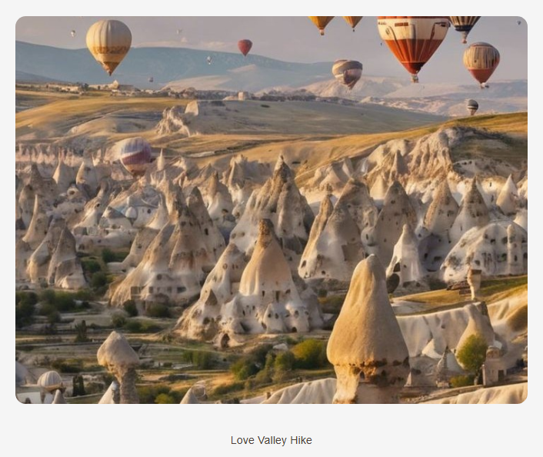

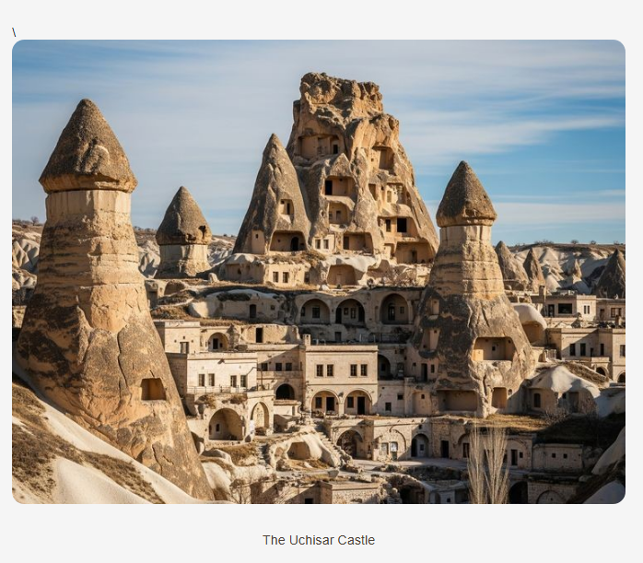

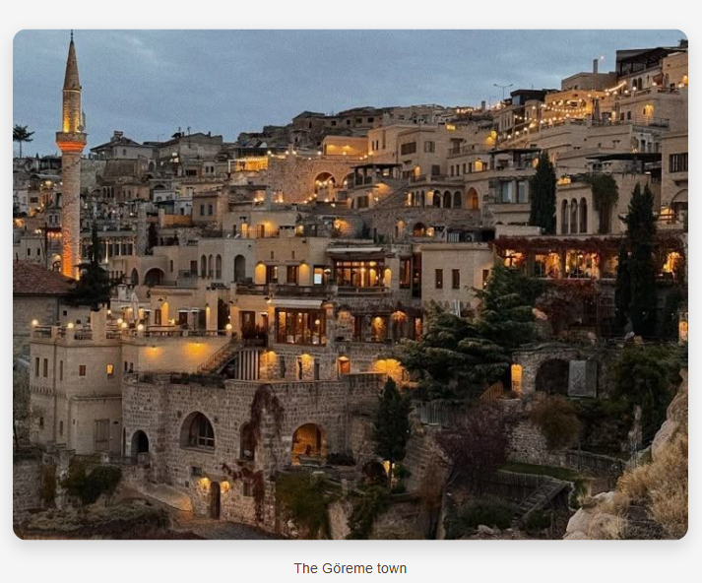

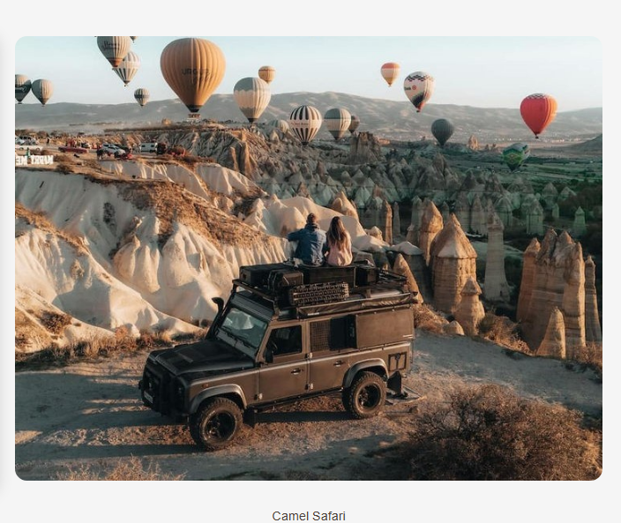

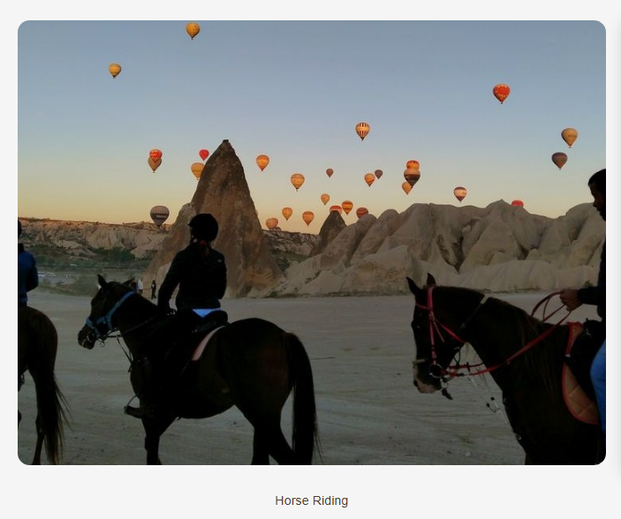

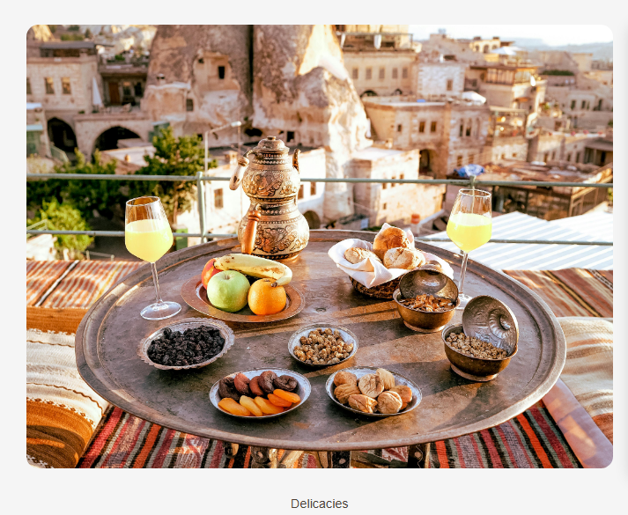

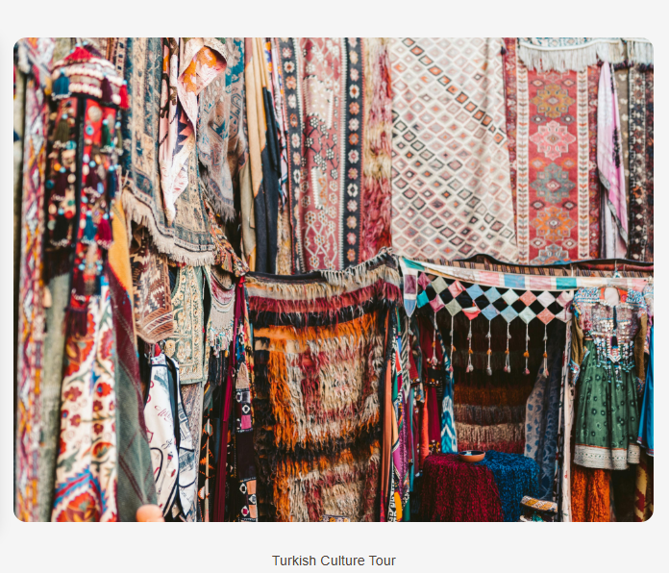

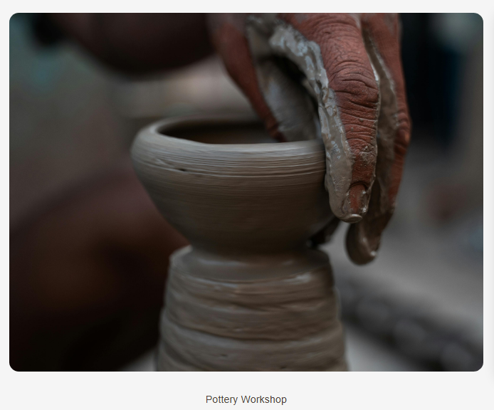

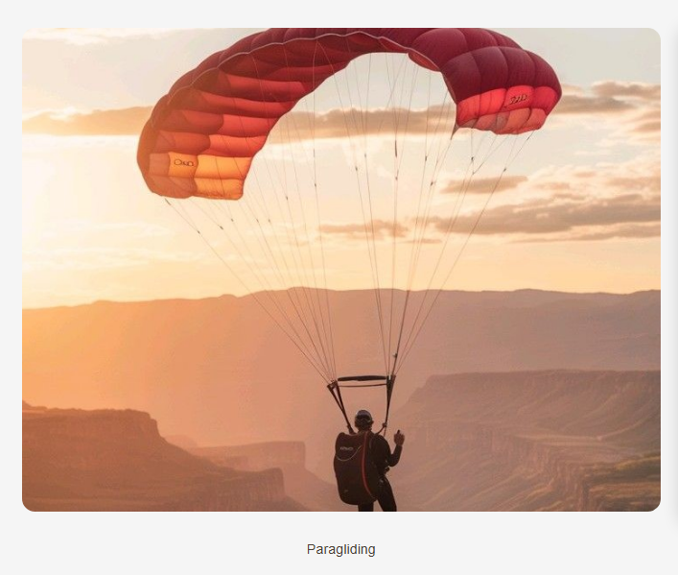

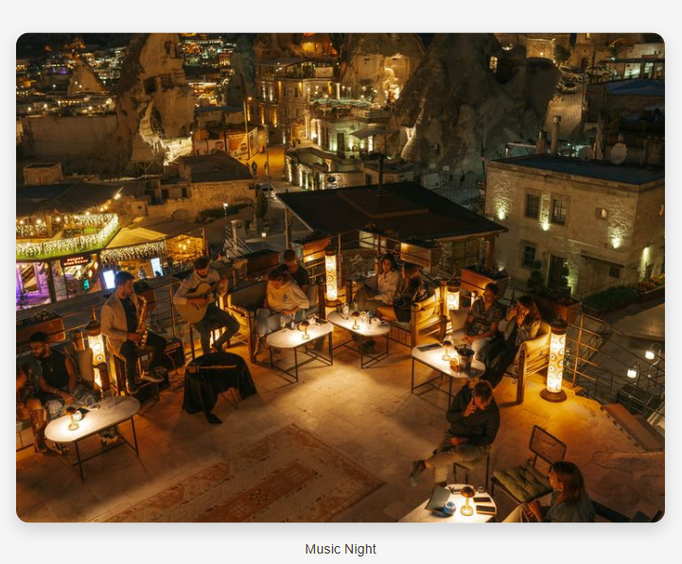

## **4.5 Contact Us Page**

* **Contact Us**

This is the last page of the website which is the “ Contact Us ” page. Here, the user can contact with the resort management. The address, email, and phone number is given for the comfort of the user so they can directly contact with the management in case of any type of query. The user can also send message through the send message section in this page. The user will be needed to enter their name, email and the desired message.

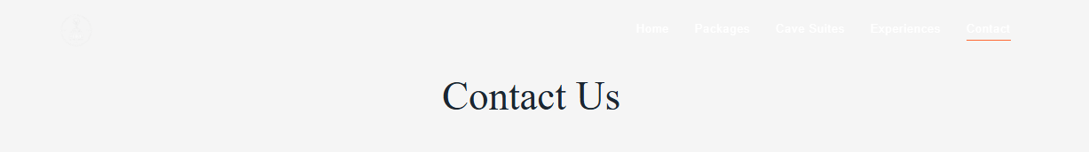

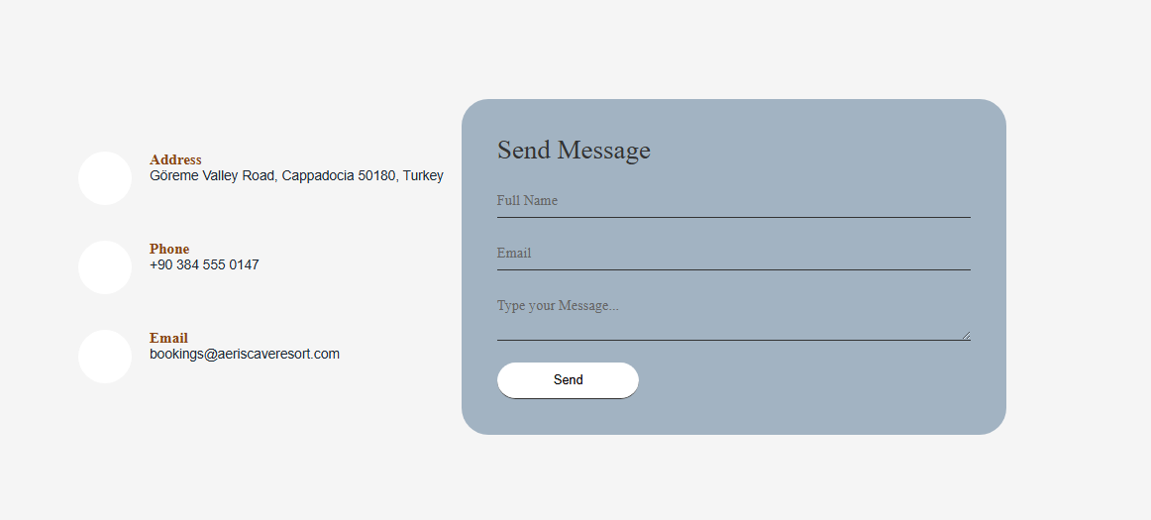

* **Booking**

The contact us page also provides the users and tourists with the booking of hotel/rooms service as well. Also, there is no fees deduction during the booking process.

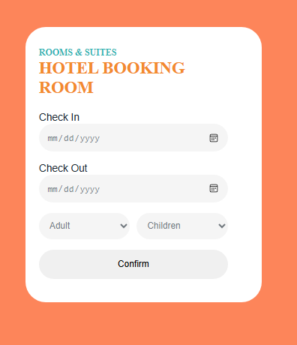

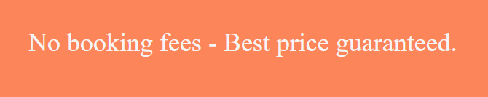

* **Google Map**



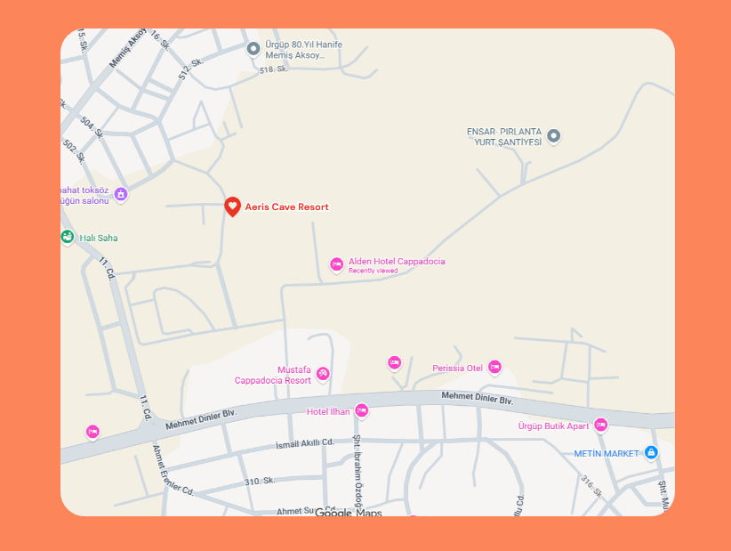

# **5. Design Choices**

## **5.1 Fonts Families:**

Two complementary font families were chosen to create a balance between elegance and readability.

* **Playfair Display (Serif)** is used for headings.
* **Montserrat (Sans-serif)** is used for body text.

## **Font Colors:**

The color palette is inspired by **earthy and natural tones**, reflecting the cave and heritage theme of Cappadocia.

* **Orange Primary Color** (#FFA500)is our main color.
* **Orange Secondary** **Color** (#8B4513) is used as the accent color.
* **Dark Text Color** (#2c3e50) is used for readability and contrast, ensuring text is easy to read.
* **Light Text Color (#f4f4f4)** is applied on dark backgrounds to maintain clarity and visual balance.
* **Blue-1 Color (#32b4b4) Is used as in the accent color.**

## **5.3 Layout and Structure Decisions**

The layout of the website was designed to be clean, structured, and user-friendly. Content is arranged in a clear visual hierarchy, with headings, subheadings, and body text properly separated. The layout is designed to be responsive, allowing the website to adapt smoothly to different screen sizes such as mobile, tablet, and desktop. A consistent layout structure is maintained across all pages to provide a uniform user experience.

# **Assets Used**

The visual and content assets used in this project were collected from various online sources such as **Pexels, Pinterest, and Google**. These assets include images and visual references that helped enhance the overall appearance of the website. All selected assets were chosen carefully to match the theme and design requirements of the project. The assets were used strictly for educational and non-commercial purposes.

# **How to Publish the site**

1. Download or clone the repository by running following code:

https://hooriyasohail90-bot.github.io/Group-8-Aeris-Cave-Resort/index.html

1. Open index.html in a web browser (Chrome, Firefox, Edge).
2. The website is live on: https://hooriyasohail90-bot.github.io/Group-8-Aeris-Cave-Resort/

**Publishing (GitHub Pages):**

* Push your files (.html, .CSS, and assets) to the GitHub repository.
* Enable GitHub Pages under repository settings.
* The site will be live at the GitHub Pages URL automatically.

# **Reflection**

1. **What Was Learned:**

* Gained practical experience in creating a complete website using **HTML and CSS**.
* Improved understanding of layout design, color schemes, and typography for a tourism-based website.
* Learned how to deploy and manage a live website using **GitHub Pages**.

**2. Potential Improvements:**

* **Improve UI design with animations and effects**

We can add more animation and effects to improve the UI design and to make the website more presentable to the user.

* **Add Additional Pages or Dynamic Content**

Creating separate pages for **booking**, **exploring rooms**, and **activities** can improve website organization and enhance the user experience.

# **Graphs and Charts ( from EXCEL )**

* **Total Revenue for Packages and Rooms**

* **Room Booking**

* **Total Revenue for Room Booking**

* **Packages**

* **Total Revenue for Packages**

# **Website Brochure**

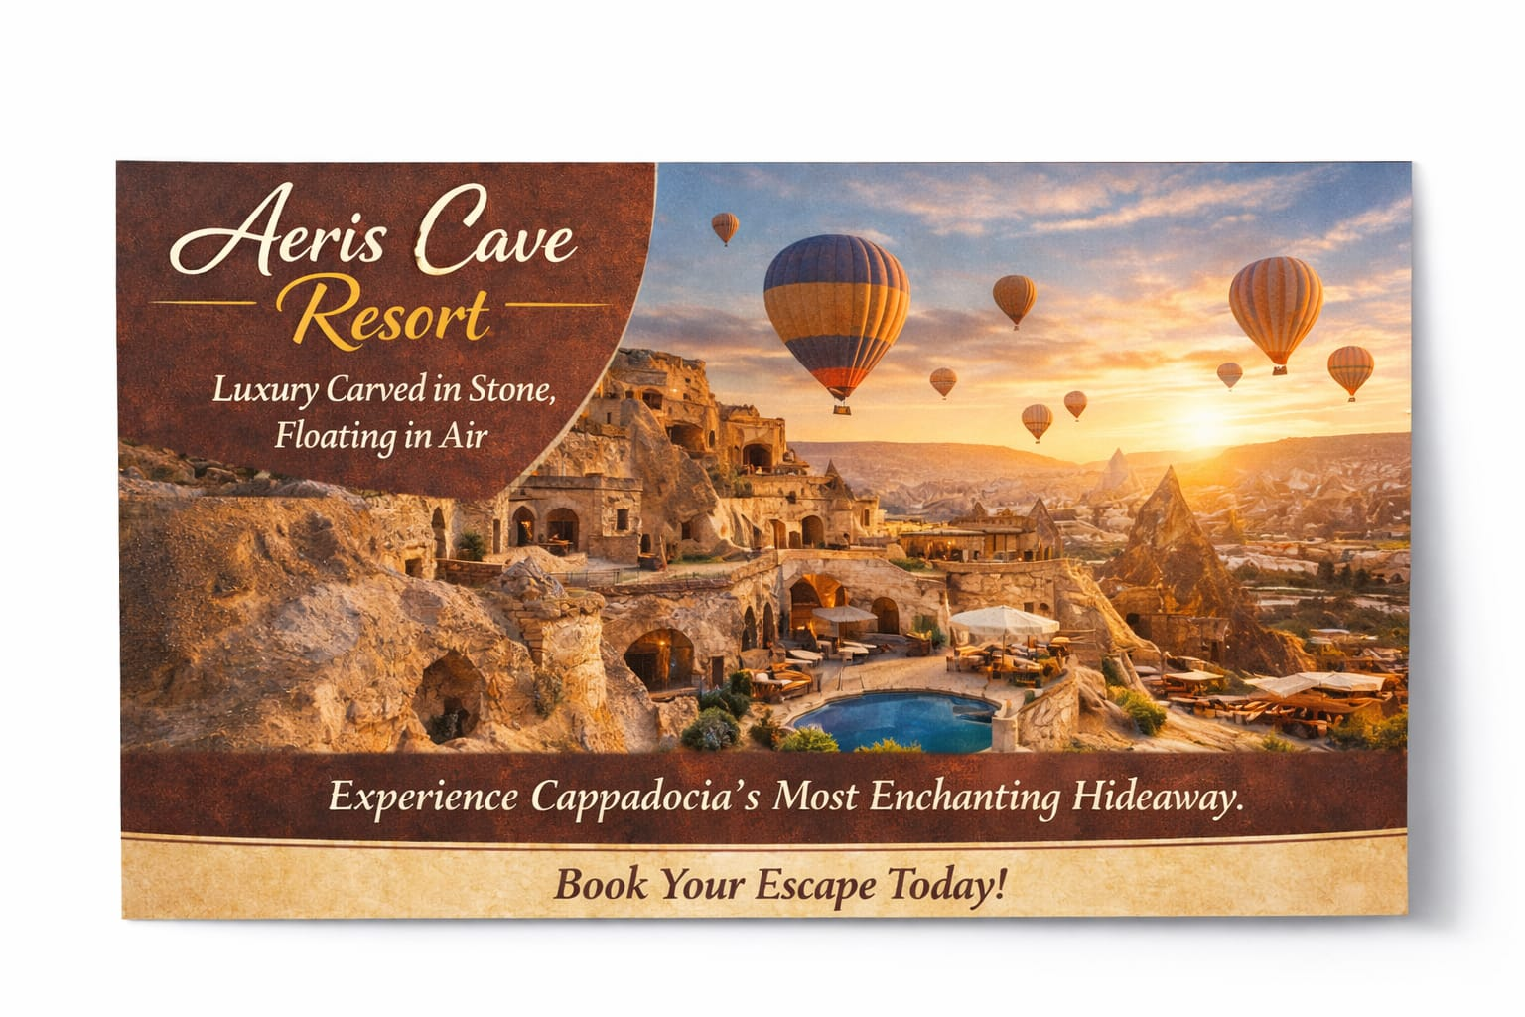

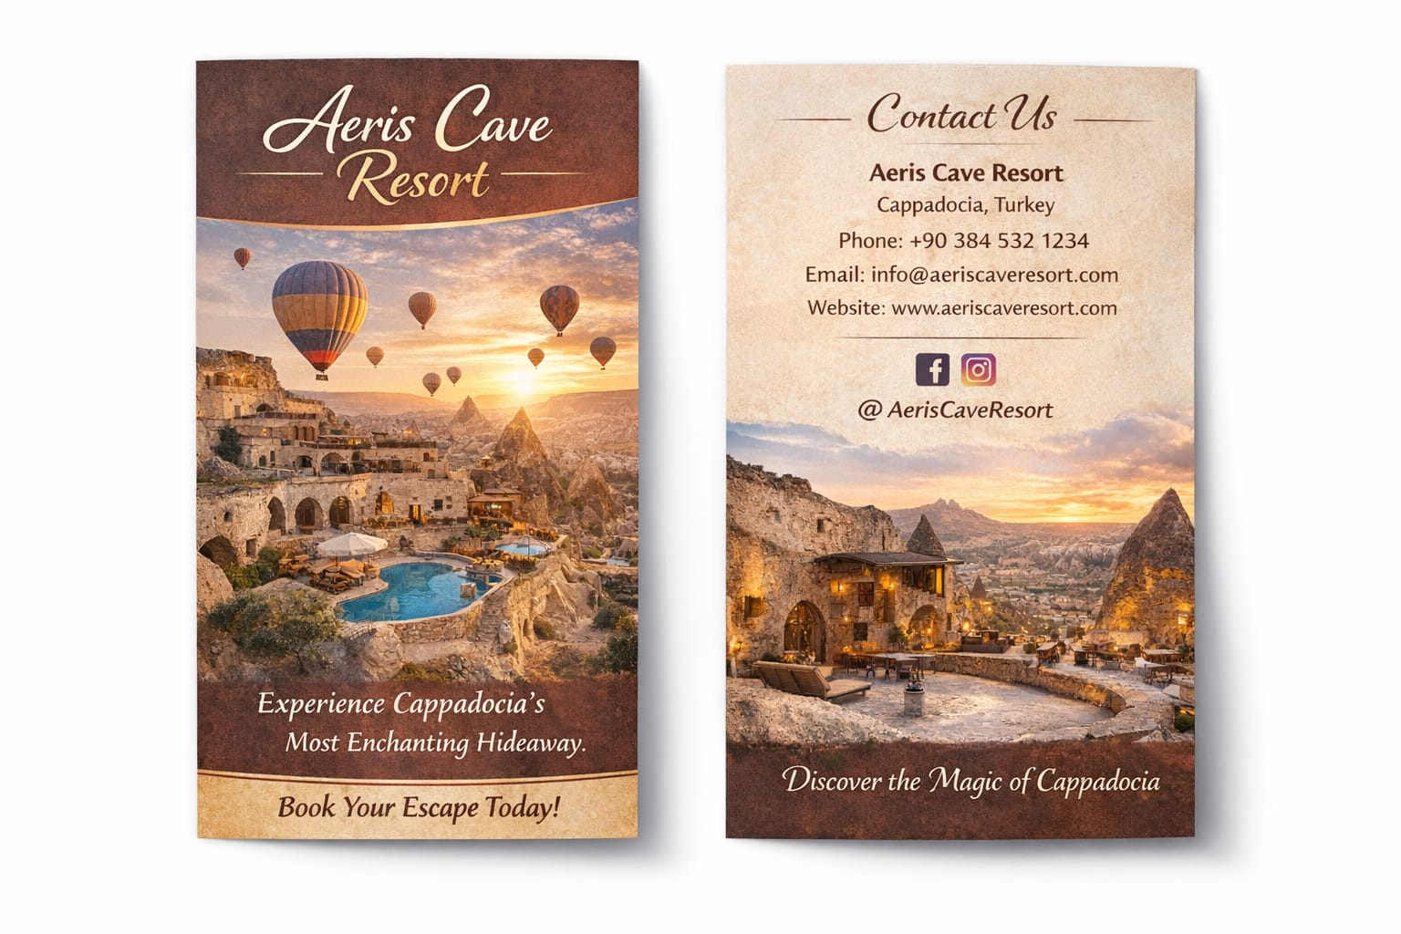

# **LinkedIn Screenshot**

